#

**Collaborative Solution 2022**

**Q1**

**a) i)**

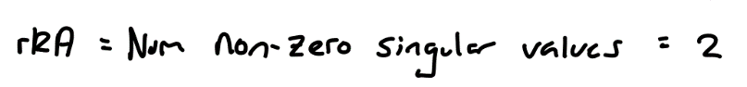

**a) ii)**

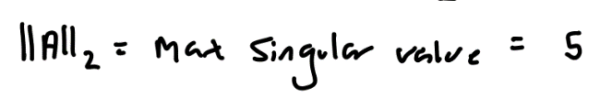

**a) iii)**

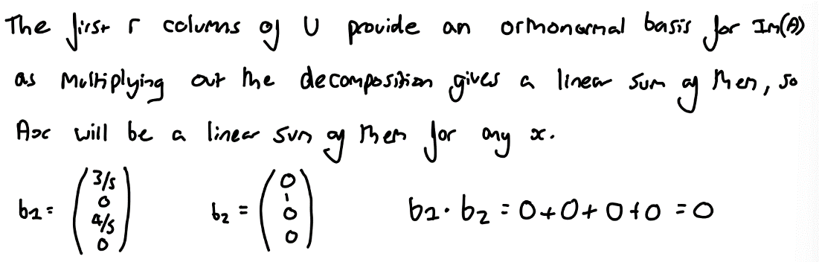

**a) iv)**



**b)**

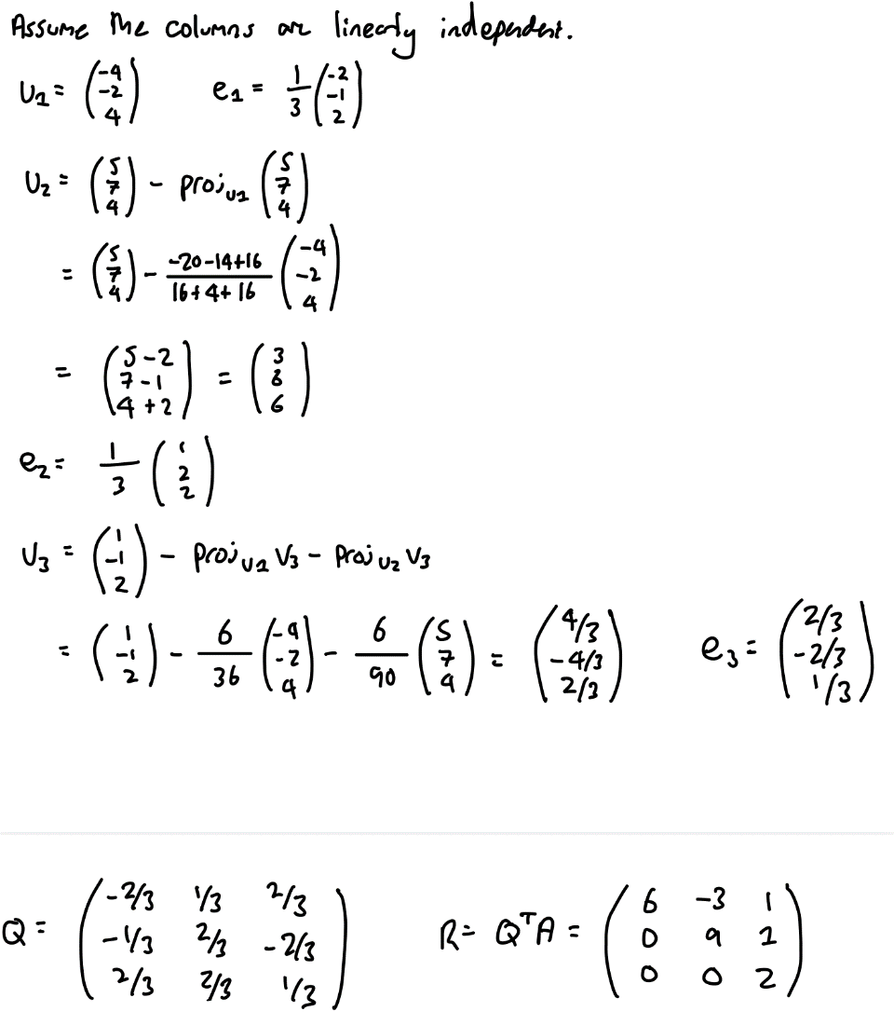

*[v3 calculation is dodgy but the final result is the same as the calculator]*

**c) i)**

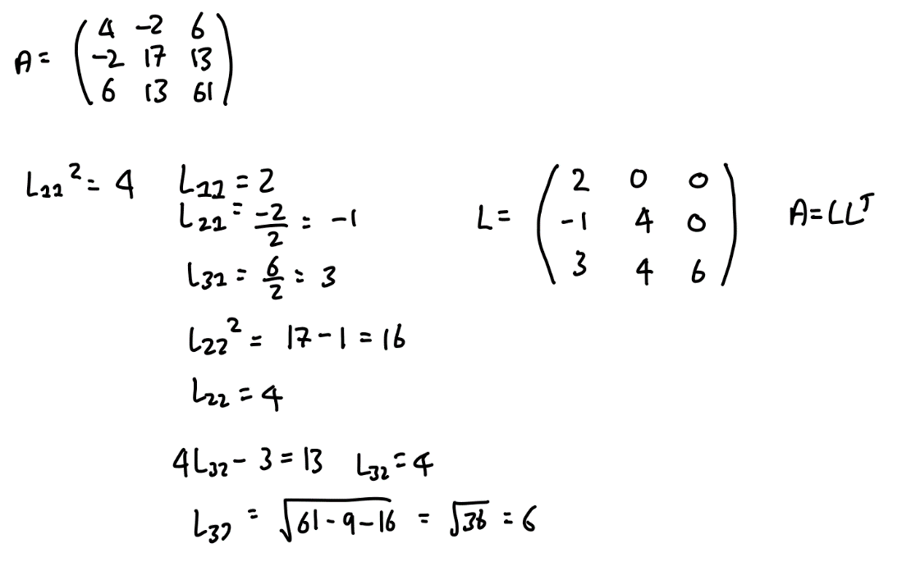

**c) ii)**

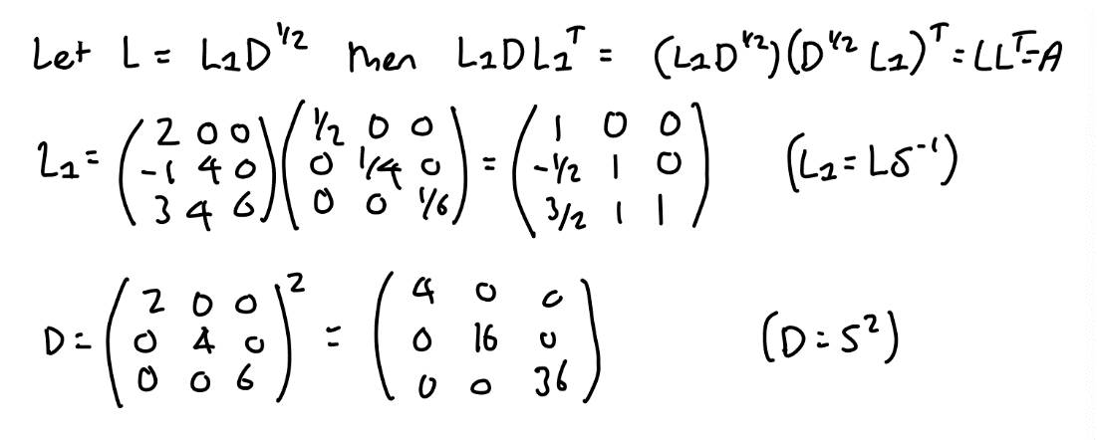

*[Where S = Diagonal of L (Thanks Wikipedia)]*

**d) i)**



**d) ii)**

u

**d) iii)**



<https://math.stackexchange.com/questions/1982680/why-is-rank-uvt-always-equal-to-1>

**d) iv)**

[**https://math.stackexchange.com/questions/1345165/eigenvalues-of-householder-matrix**](https://math.stackexchange.com/questions/1345165/eigenvalues-of-householder-matrix) **- I think 1 is also an eigenvalue depending on n?**

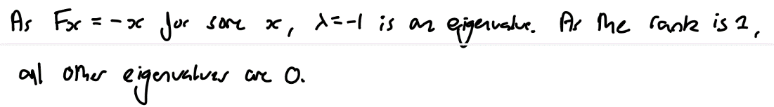

Alternative solution:

It's clear from the geometric properties of the transformation that vectors parallel to u (i.e. ku) will become -ku - eigenvalue -1.

Vectors parallel to the plane are unchanged by reflection - i.e. x remains x - eigenvalue 1.

We don't need to consider the case where we have some vector x with some component parallel to the plane as well as some other component perpendicular to the plane. Here's why.

Any vector x can be decomposed into two components: one parallel to u and one in the hyperplane. Let's call these components x_parallel and x_perpendicular, respectively:

x = x_parallel + x_perpendicular

Now, let's apply the transformation F to the vector x:

F(x) = F(x_parallel + x_perpendicular)

Since F is a linear map, we can write:

F(x) = F(x_parallel) + F(x_perpendicular)

As we've established before, for a reflection transformation, F(x_parallel) = -x_parallel and F(x_perpendicular) = x_perpendicular. Thus:

F(x) = -x_parallel + x_perpendicular

F(x_parallel + x_perpendicular) = -x_parallel + x_perpendicular

If we set this equal to lambda * x = lambda * (x_parallel + x_perpendicular), we get (after some rearrangement):

(lambda + 1)(x_parallel) = (1 - lambda)(x_perpendicular)

In other words, we get that some scalar multiplied by x_parallel equals some other scalar multiplied by x_perpendicular.

This is not possible (I think) intuitively, so there are no eigenvalues to consider from this third case.

Therefore, we ignore this case.

Since there were really only three cases to begin with (parallel to plane, perpendicular to plane or none of the above), we know we have found the only eigenvalues.

**d) v)**

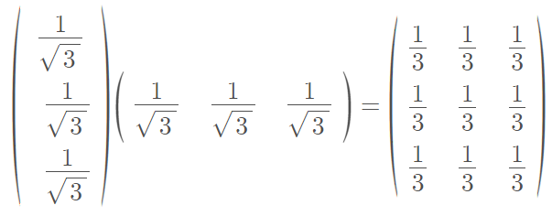

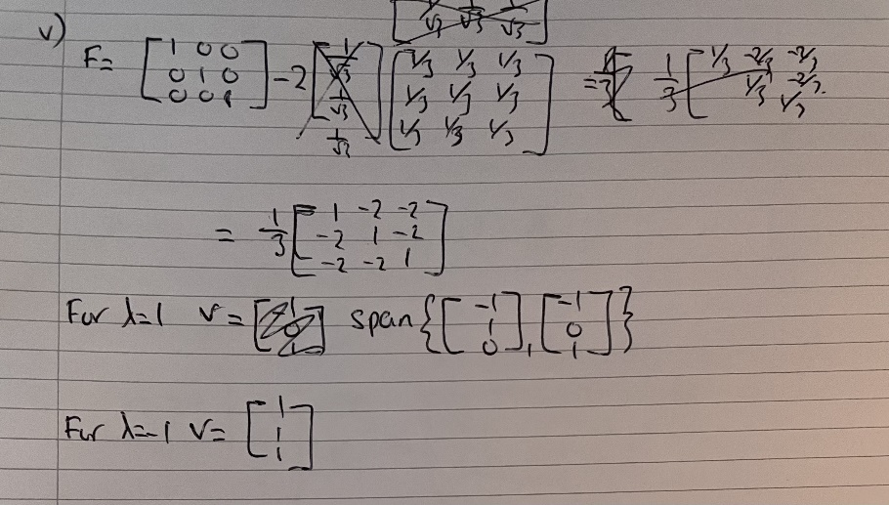

**Q2**

**a) i)**

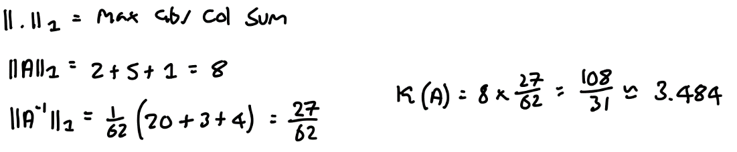

**a) ii)**

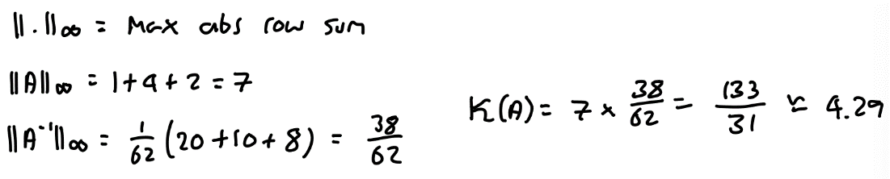

**b) i)**

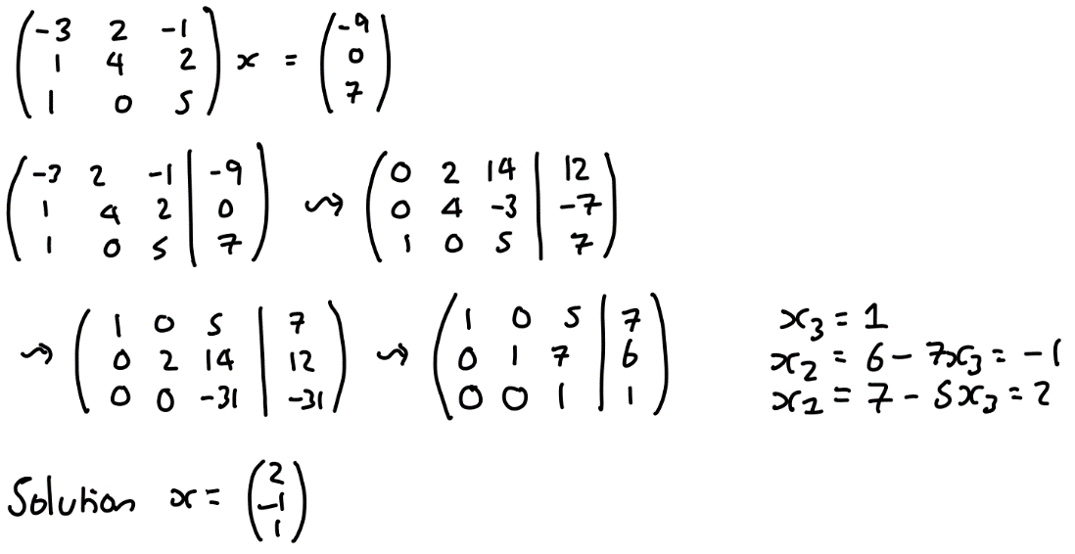

**b) ii)**

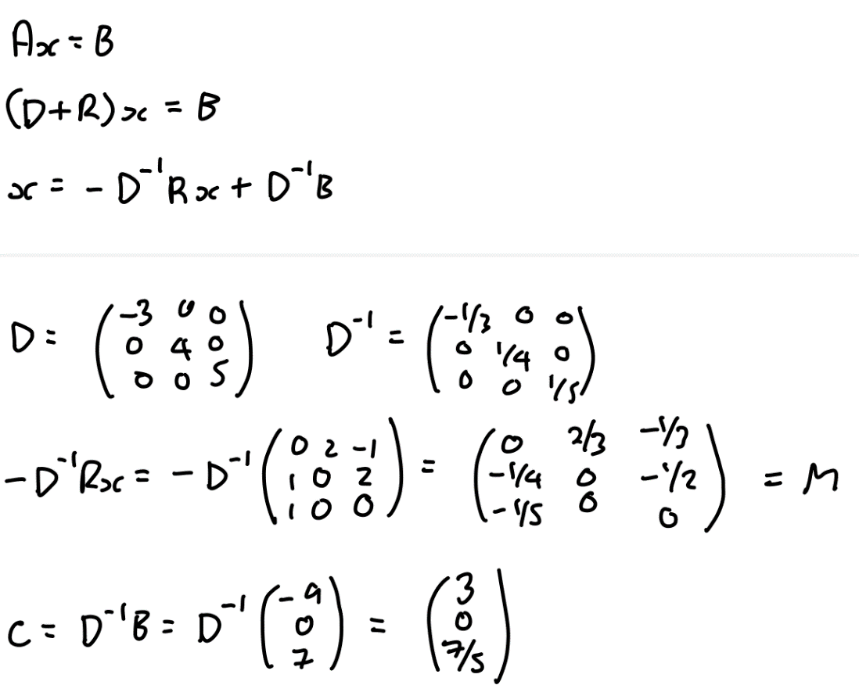

**b) iii)**

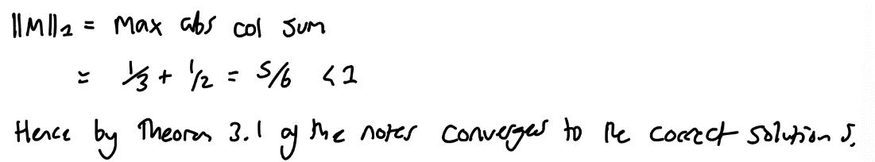



**b) iv)**

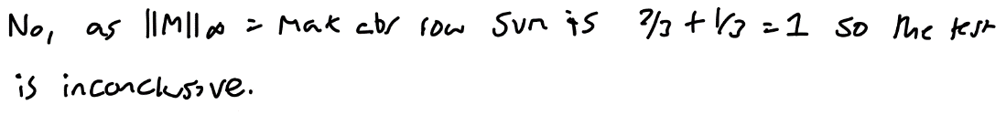

**c) i)**

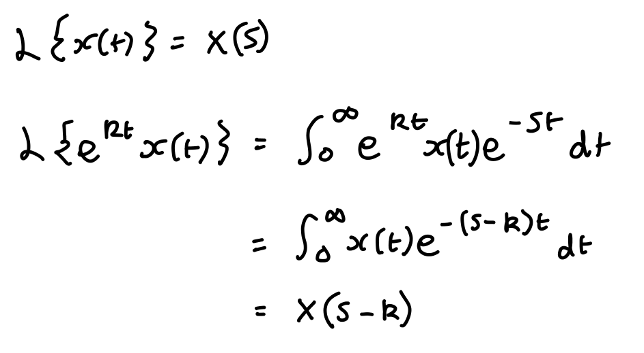

**c) ii)**

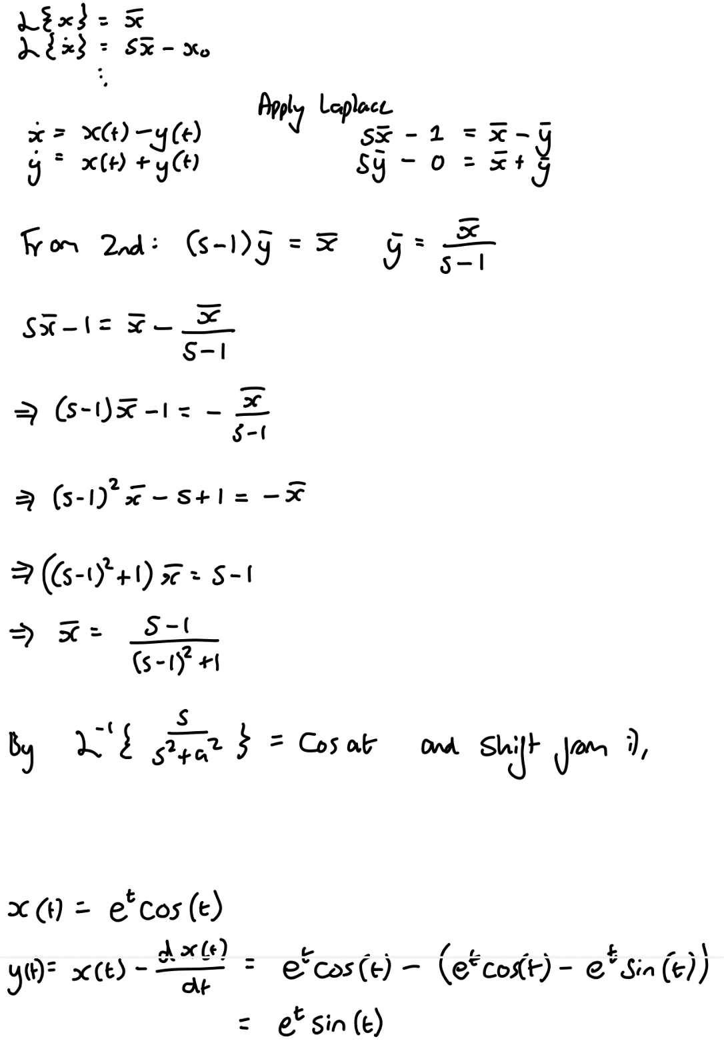

**d) i)**

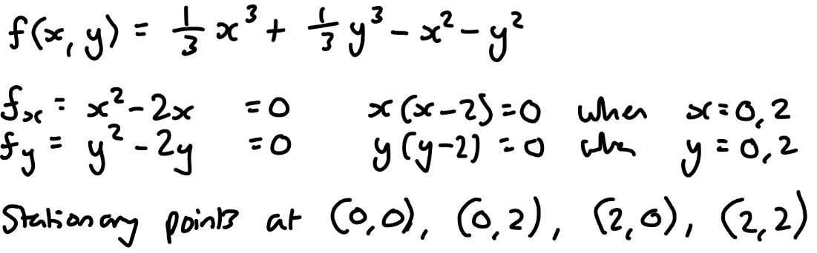

**d) ii)**

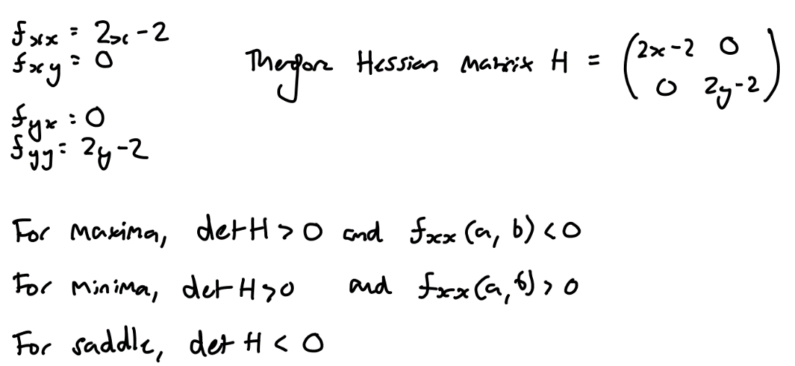

**d) iii)**

